Assignment 1

*Name: Muhammad Maaz Khan*

*Class: Se-5B Roll: Se-221053*

*Course:* ***Computer Networks***

*By* ***Sir Wilayat***

**Q1**: Create three different VLANs using a single switch and 3 nodes in each broadcast domain. i-e vlan10, vlan20 and vlan30 Configure the above scenario using the command line interface. (No GUI)  
  
  
  
  
  
  
  
  
  
  
We need one Switch and 9 PC’s to perform this Activity.  
  
  
  
  
  
  
  
  
  
  
**Step 1:**  Setting the Switch and PC’s  
  
  
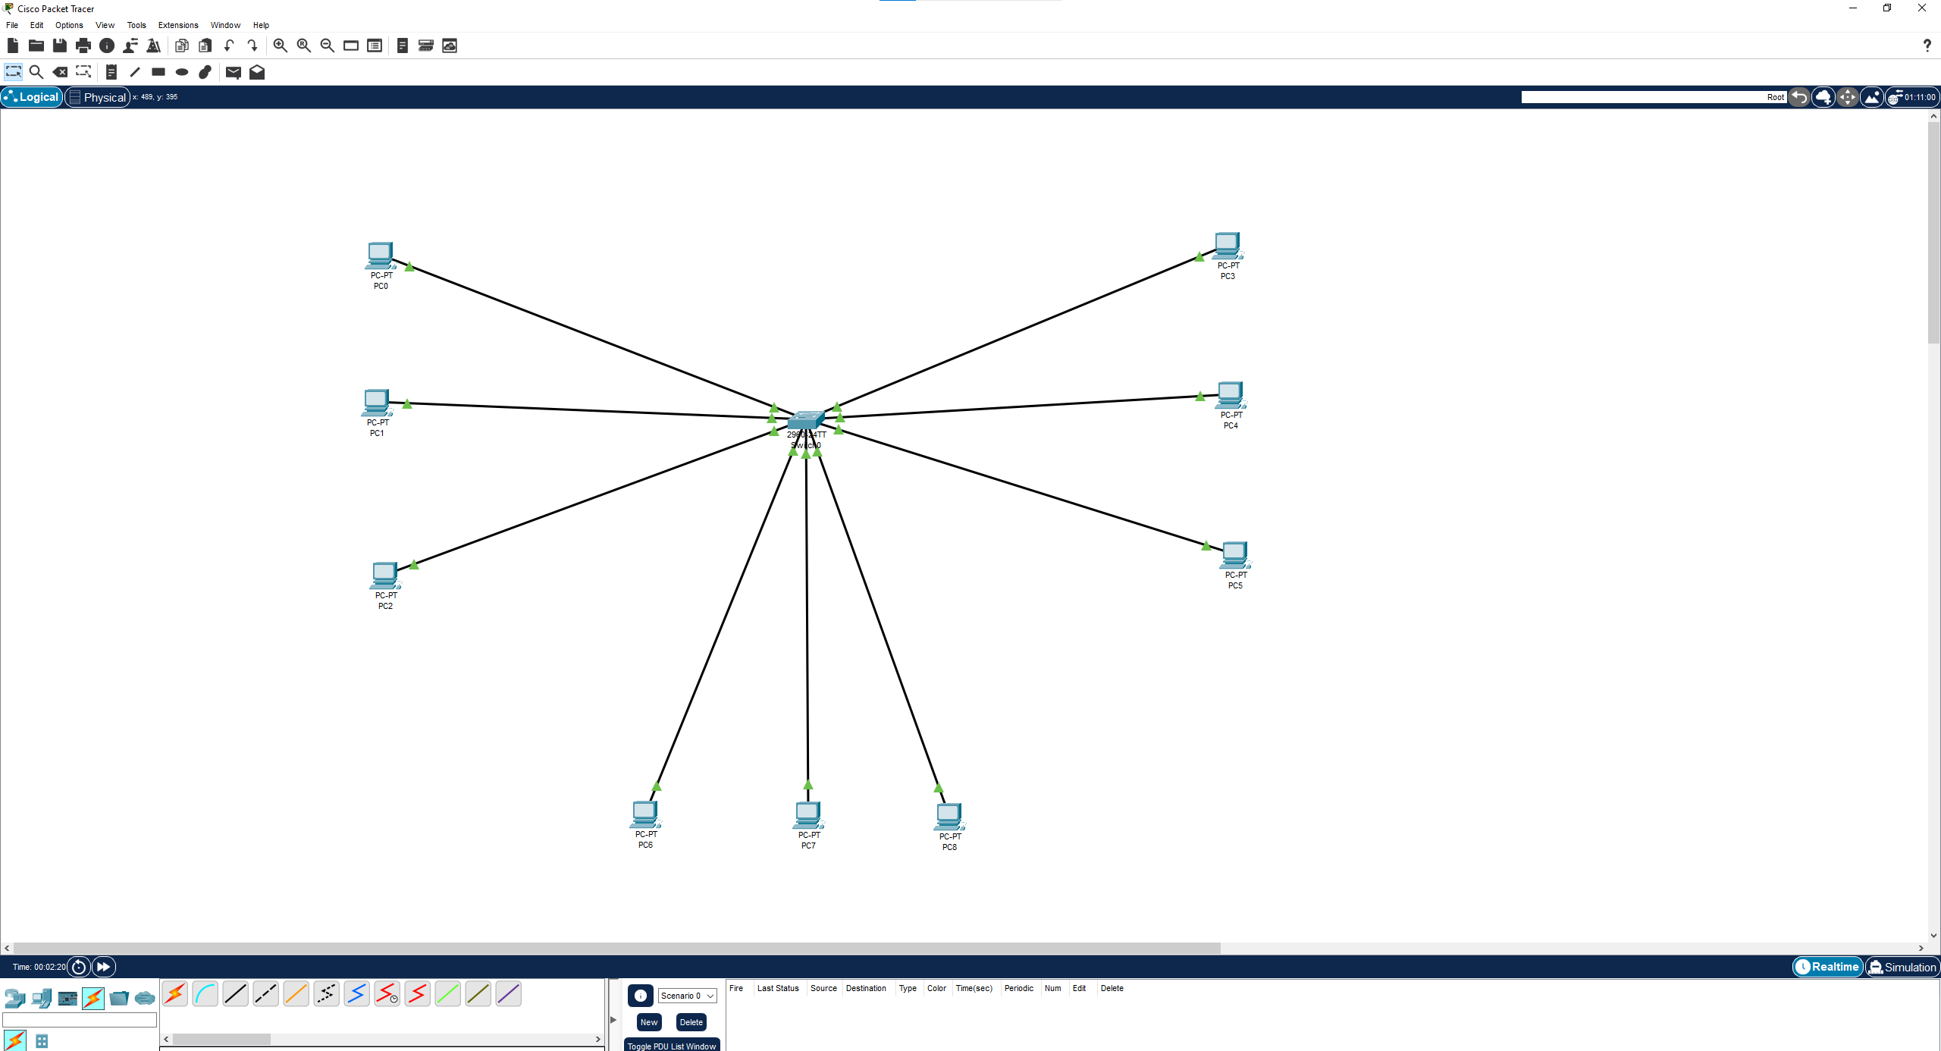  
  
  
  
  
  
  
  
  
  
  
  
  
  
  
  
  
  
  
  
  
  
**Step 2:** Coloring and labeling them with Ip’s and vLans  
  
  
  
  
  
  
  
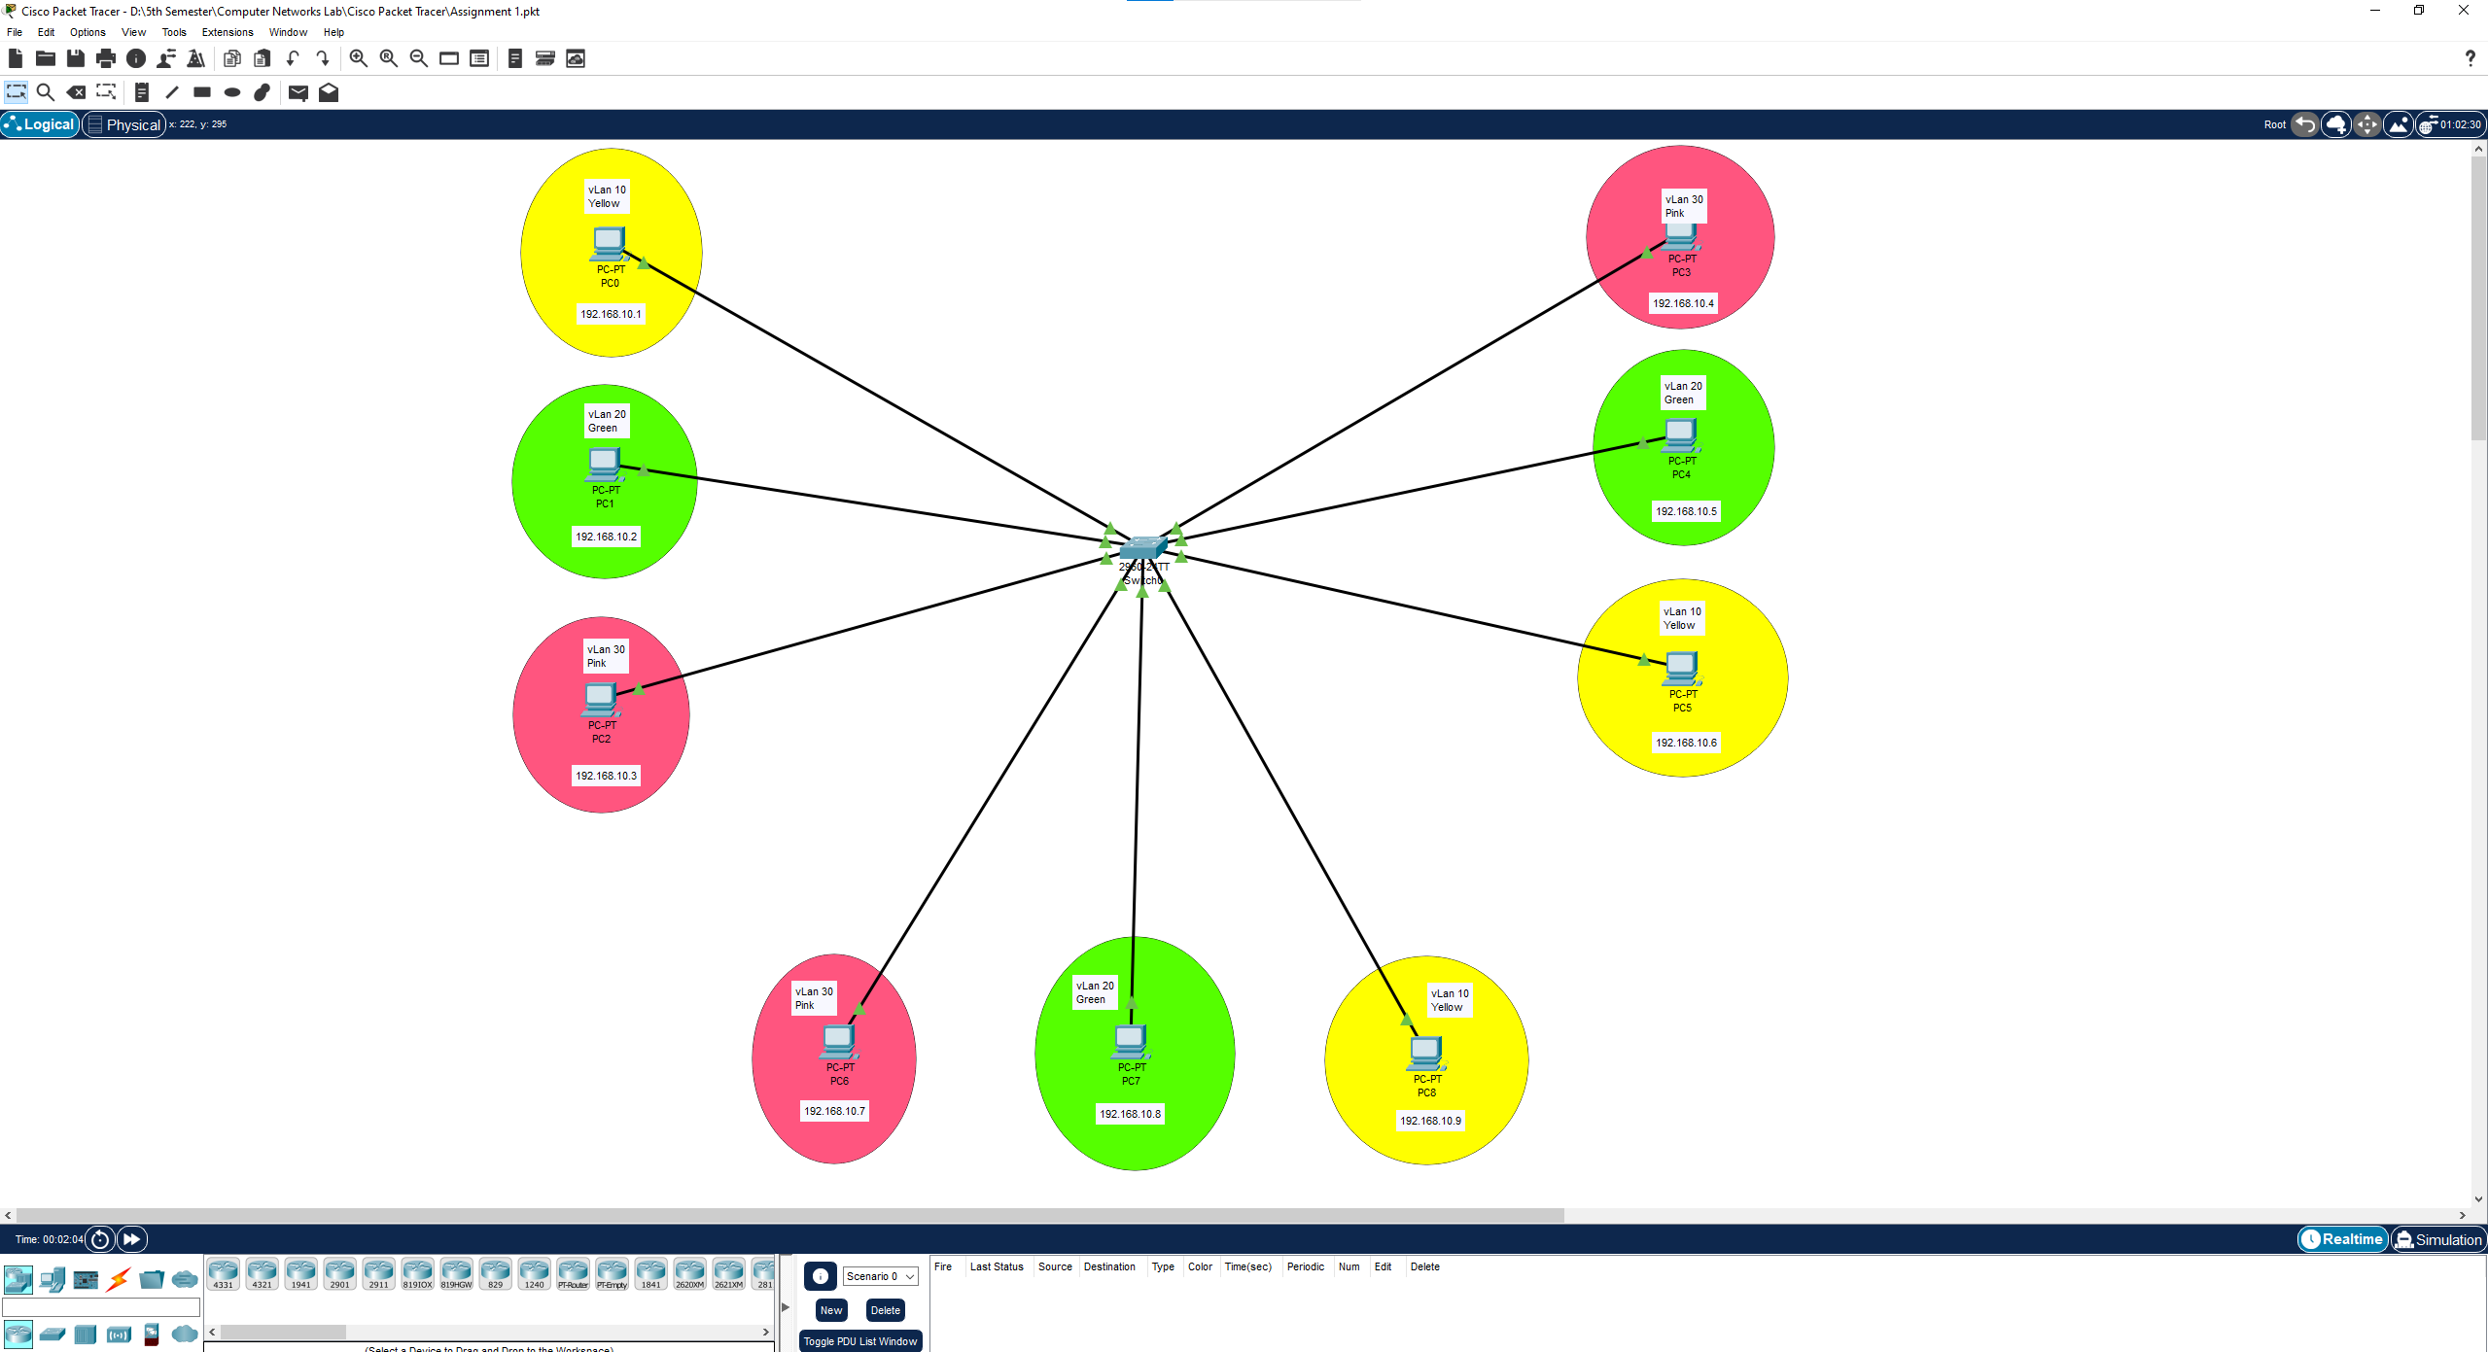  
  
  
  
  
  
  
  
  
  
  
  
  
  
  
  
  
**Step 3:** Assign the IP to each NINE PC’s Through ex I will assign PC 0 to 192.168.10.1   
PC 1 to 192.168.10.2 and so on.  
  
  
  
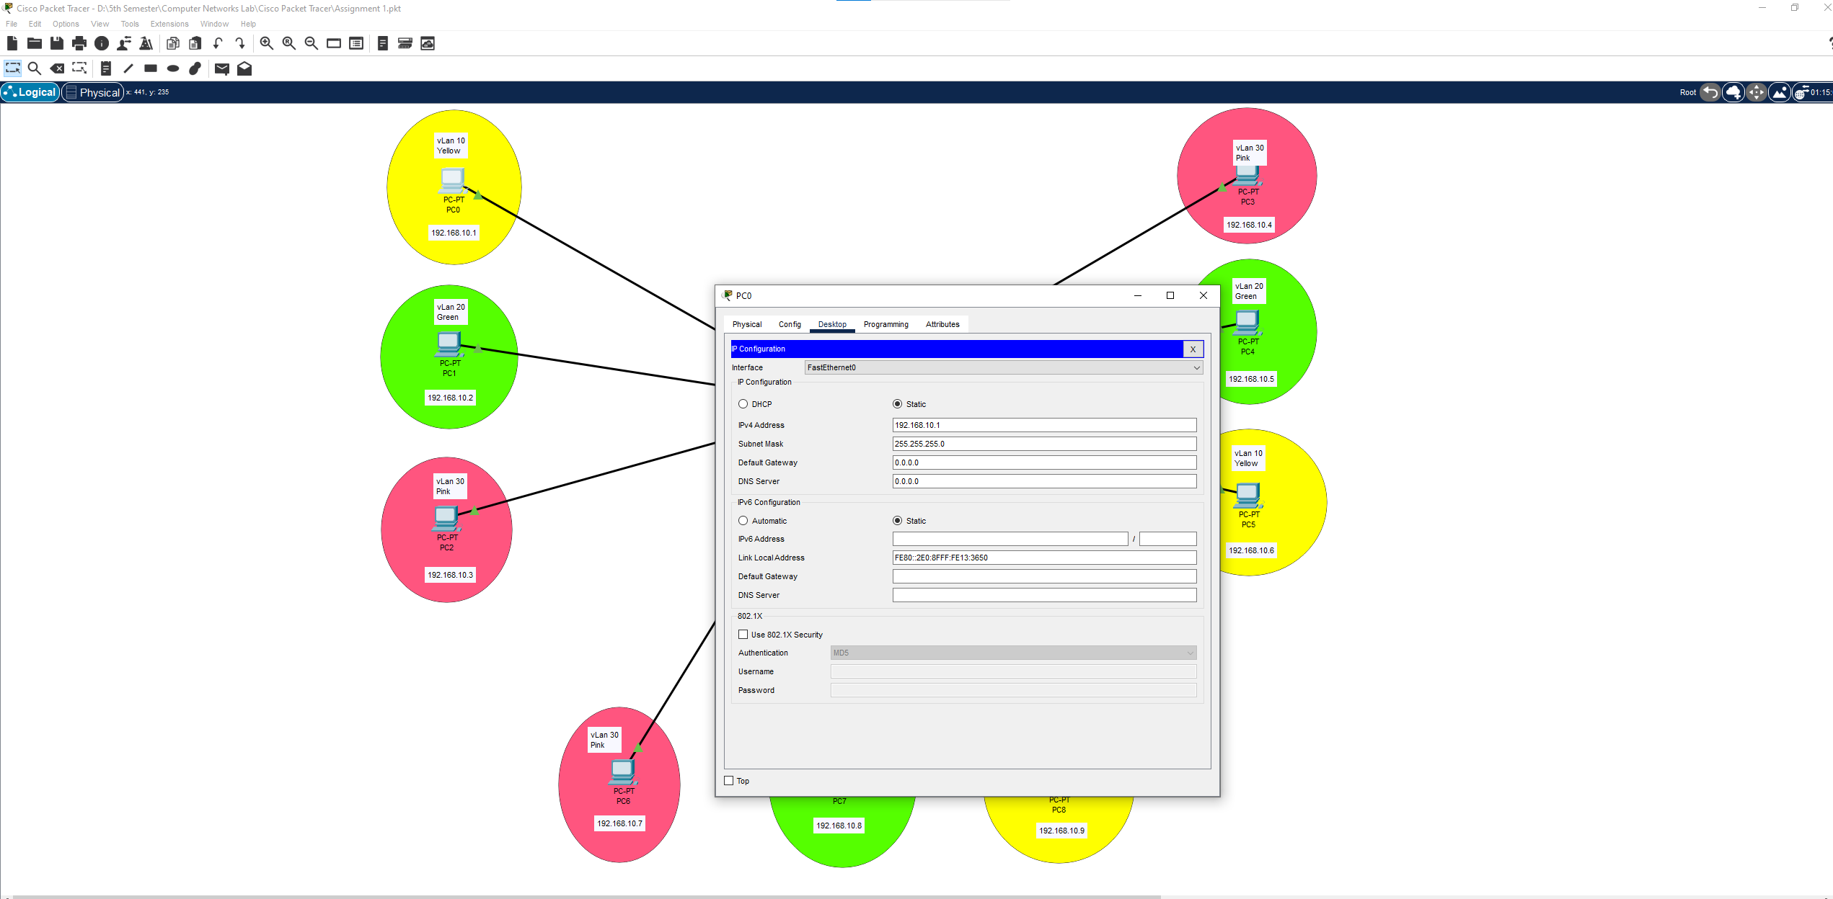  
  
  
  
  
  
  
  
  
  
  
  
  
  
  
  
  
  
  
  
  
  
**Step 4:** Now I will Enable the global configuration mode then Create vLans assign the names  
  
for example:  
  
vLan 10 ---- HR  
vLan 20 ---- IT  
vLan 30 ---- Finance  
  
  
  
First click to the switch then go to the CLI then write the following commands as shown in the PIC  
  
  
  
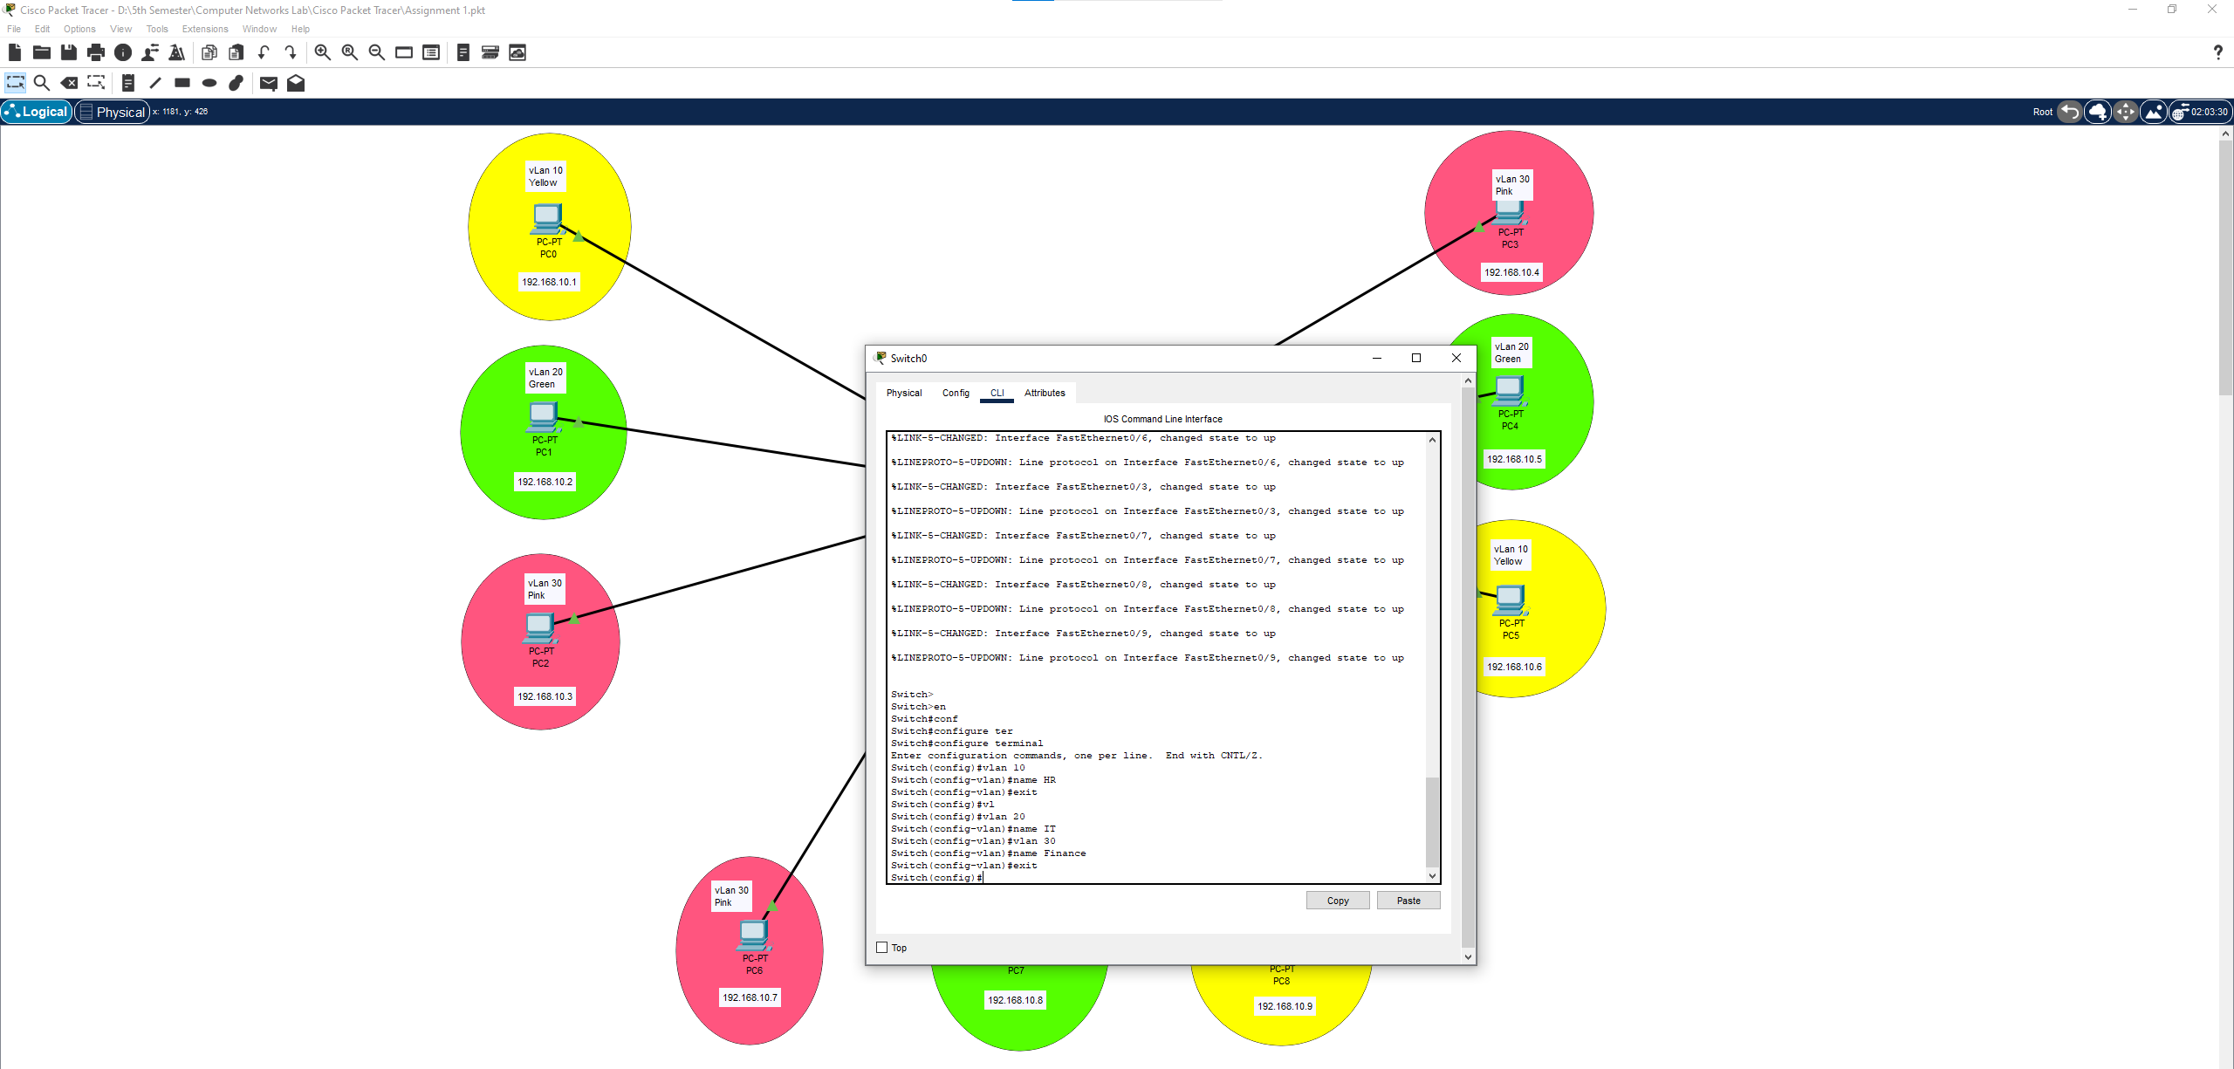  
  
  
  
  
  
  
  
  
  
  
Through vLan commands Show vLan brief we can see the configurations  
  
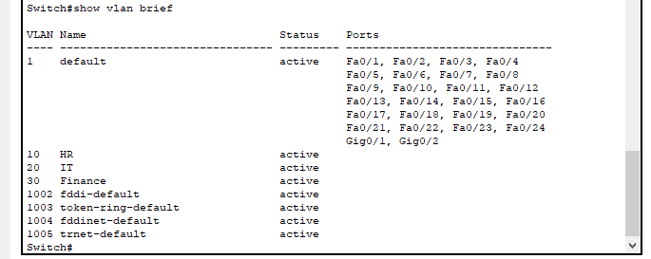  
  
 **Step 5:** Now I will Assign the switch ports to the respective VLANs.  
  
  
  
**FOR vLan 10 ( HR ) fast Ethernet 0/1 , 0/6 , 0/9**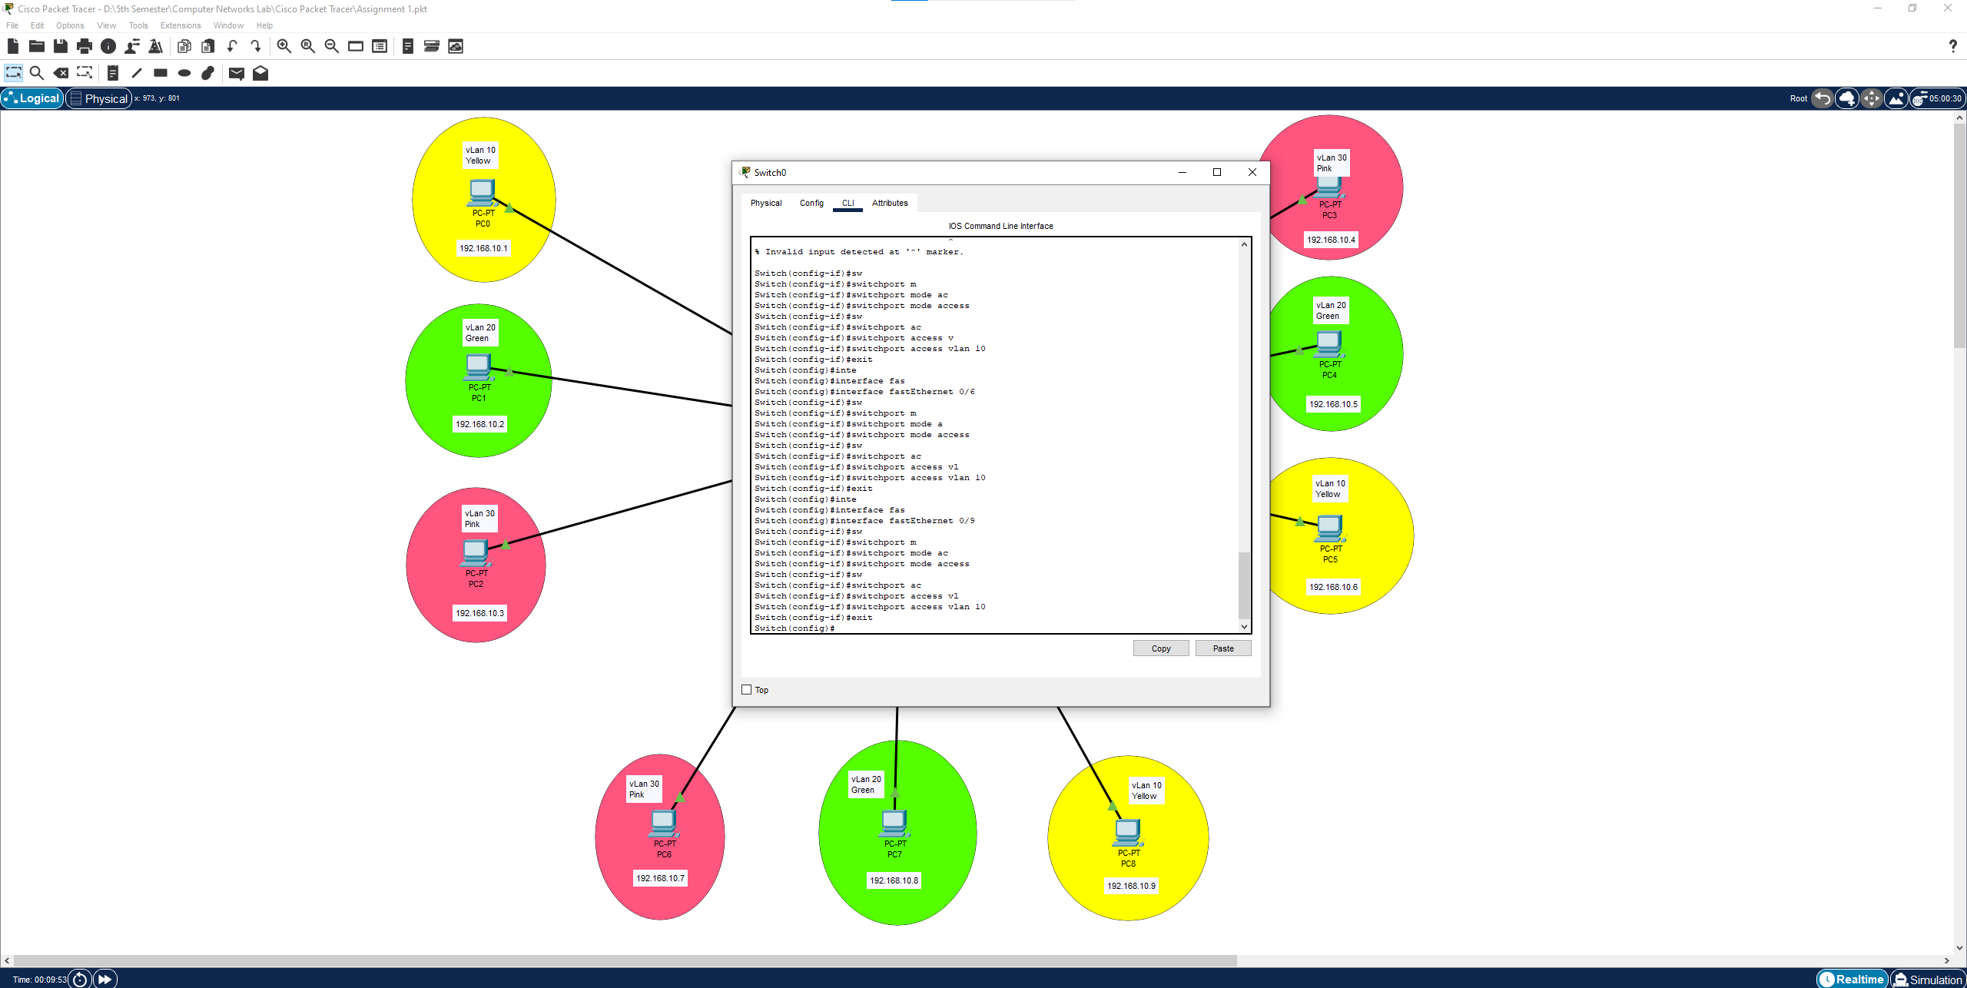  
  
  
  
  
  
**FOR vLan 10 ( HR ) fast Ethernet 0/2 , 0/5 , 0/8**  
  
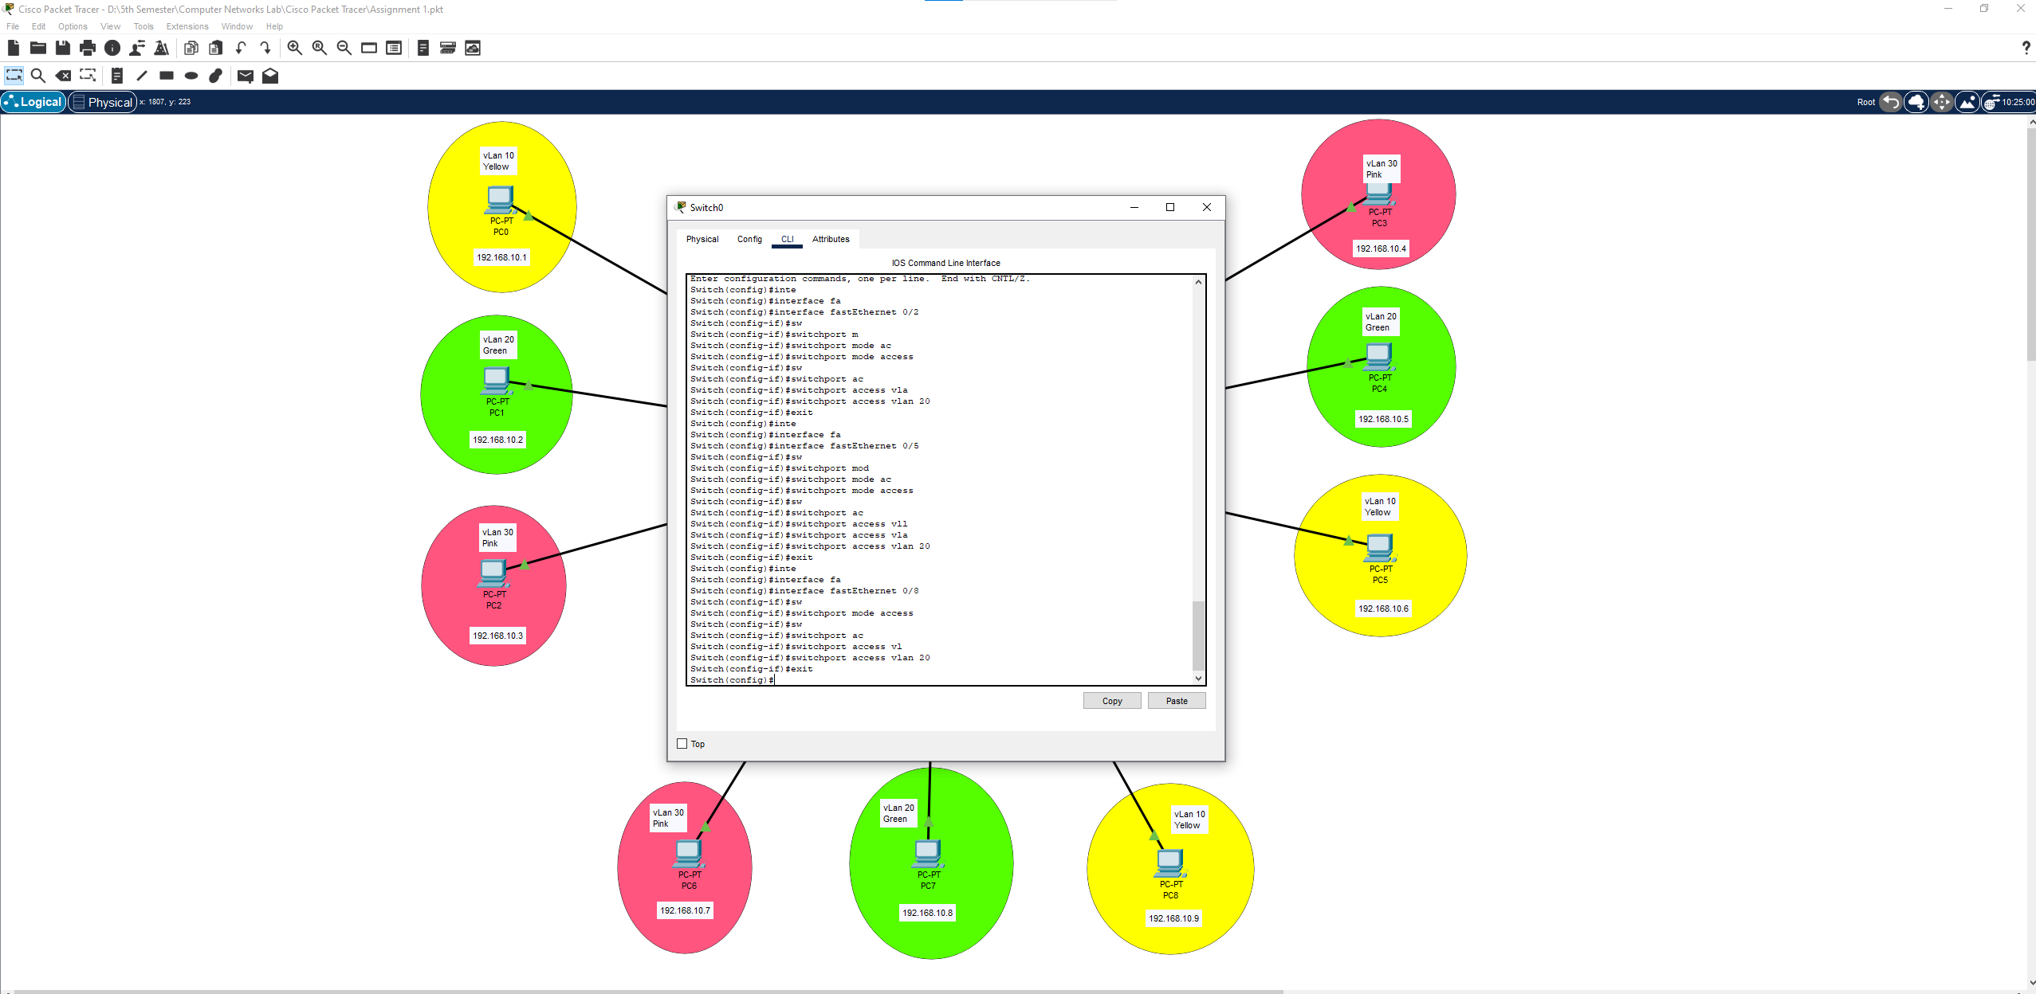  
  
  
  
  
  
**FOR vLan 10 ( HR ) fast Ethernet 0/3 , 0/4 , 0/7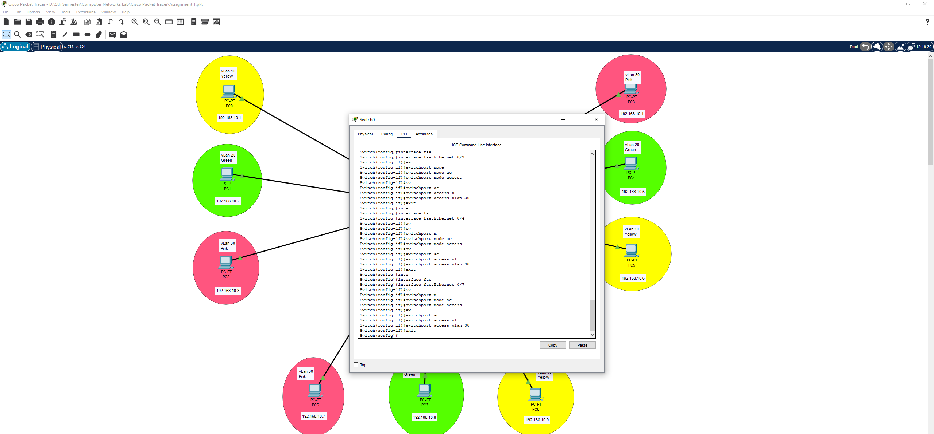 Step 6 :** Now all Configuration is done let’s check through the command  
  
***SHOW VLAN BRIEF***  
  
  
  
  
  
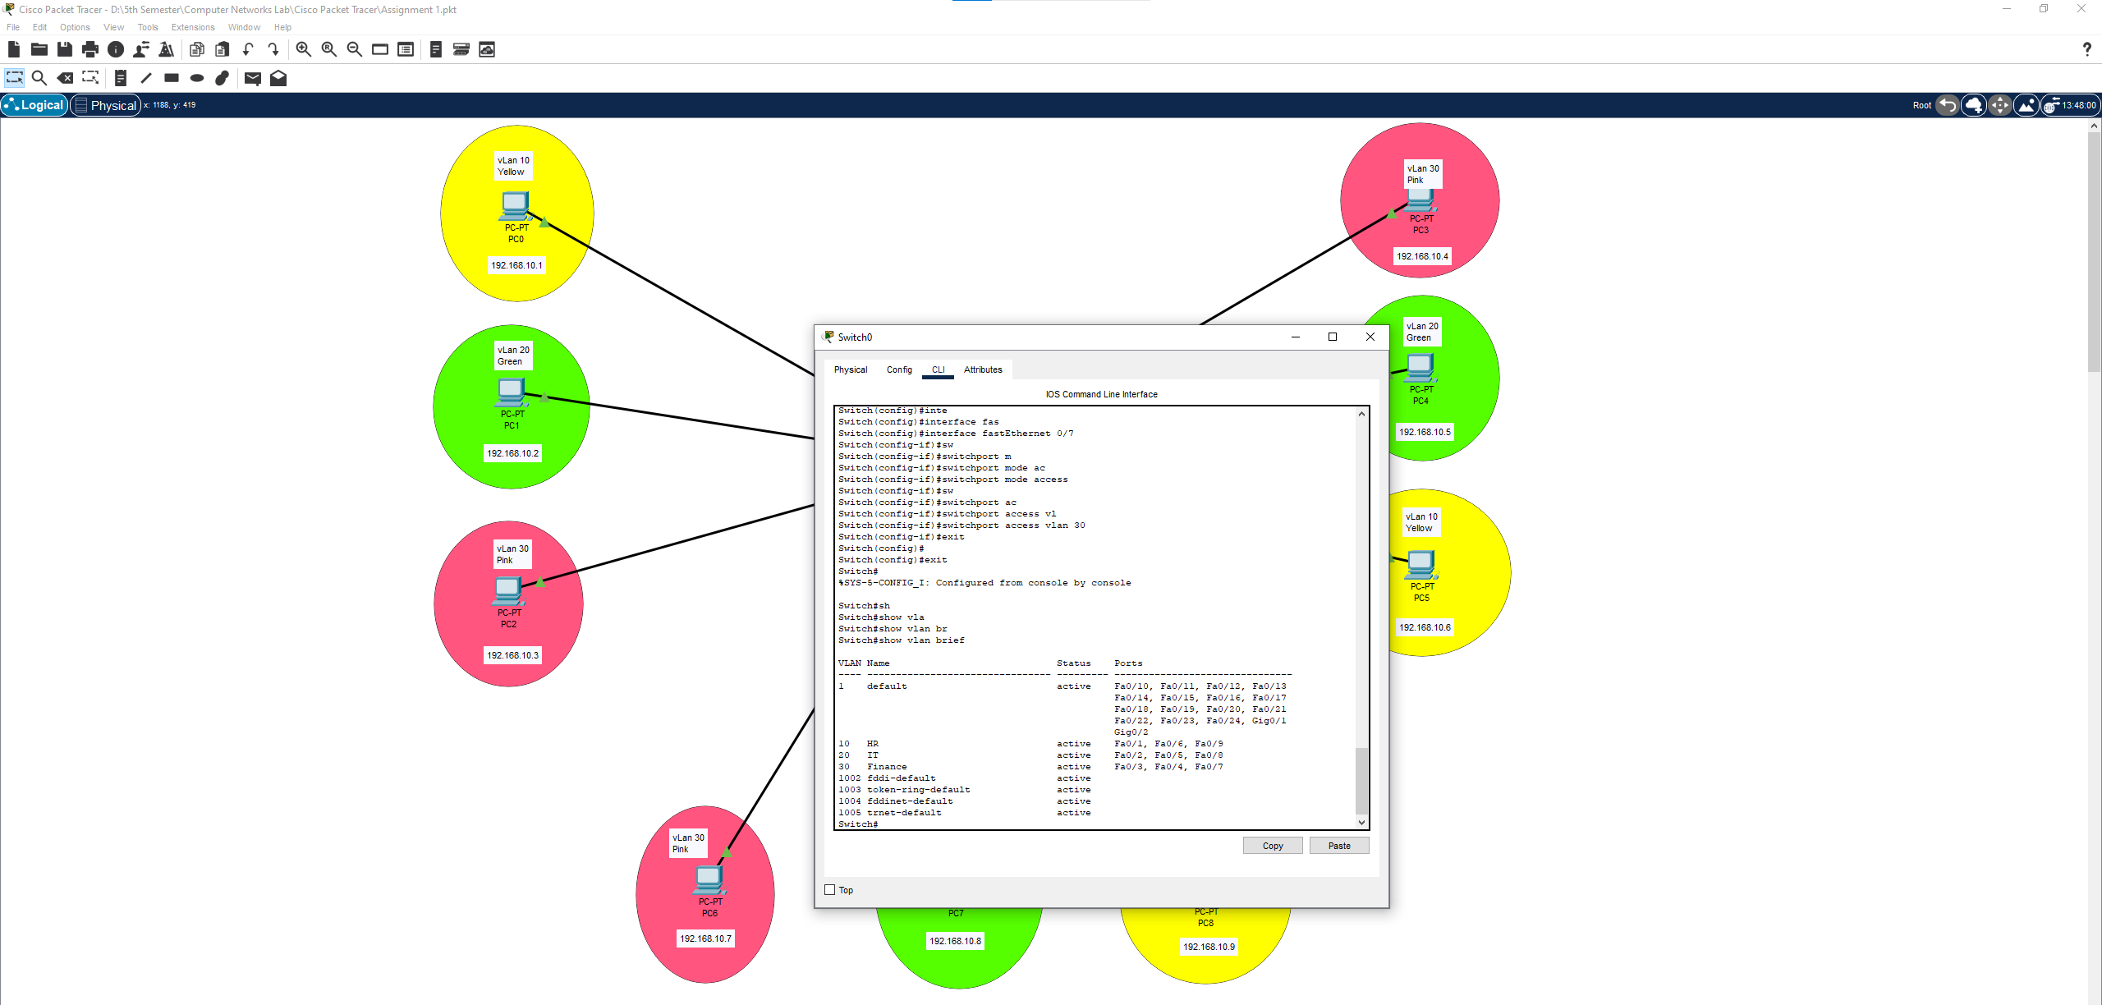

as you can see all the ports are connected to the specific vLan’s   
  
  
  
  
  
  
  
  
  
  
  
**Step 7 :** Lets check by sending some packets   
  
